+

Do It Tomorrow

Summary

For this project we are going to be creating a Tank game. The game will be 3D based and will be programmed in XNA. It will be based on the 1980 arcade game “[BattleZone](http://en.wikipedia.org/wiki/Battlezone_(1980_video_game))”. The game will make use of 3D vector graphics. We will be using blender for 3D renders as it is open source.

Below are screenshots of the original BattleZone game:

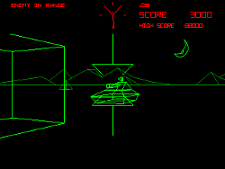 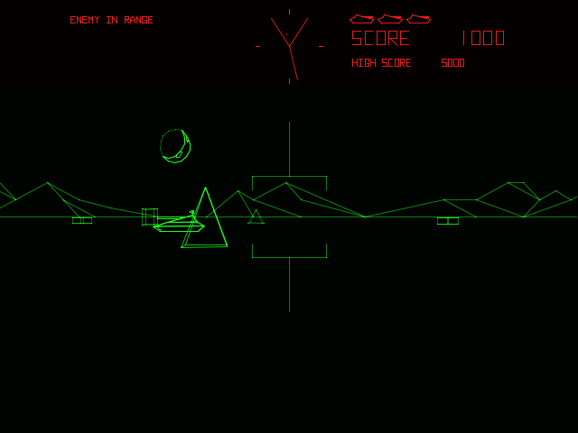

The team has experience with the XNA framework which is a framework used to make games. This makes it the ideal tool for us. We will be working to get a playable prototype up and running in the coming weeks and we plan on bringing the game to this year’s Games Fleadh. The theme to Games Fleadh this year is Robot Tank by Activision. That game was basically a clone of the original 1980 BattleZone game.

We have decided to make our game as similar as possible to the original BattleZone game. We want to make us of wireframe graphics and use a similar control system. As well as this we want to add a few features that weren’t in the 1980 version. We would ideally like to get radar set up so that the player can easily locate the enemy once they go out of sight.

Version History

The design document has been a work in progress throughout the project. Because of this, there have been several versions of it. This version is our final design that we are submitting.

# Version 0.1

This is the first version of the design document. It includes all of our UML diagrams. This version was completed on 21st February 2013.

# Version 0.4

I have included more in this version according to our progress in the project so far. This version was completed on 7th March 2013.

Game Overview

The game that we are creating is going to be a clone of the 1980 game produced by Atari called “BattleZone”. We will be creating our game using newer technologies than those that were available when the game was originally created so we hope to be able to add more modern features such as radar to the game.

BattleZone was significant in the gaming industry as it effectively was the first first-person shooter game and created a genre that would go on to dominate gaming in the years to come. It used 3D graphics and vector animation to create a more immersive gaming experience.

It’s little wonder so that when the game was released in November 1980 it became a huge hit. Gamers were treated to a 3D gaming experience like they had never seen before. The game represented the birth of 3D gaming.

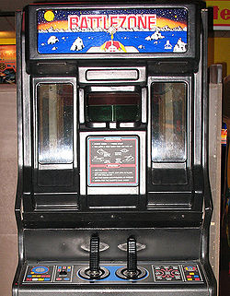

-The game was originally an arcade game. It has since been ported to many different platforms.

# BattleZone Gameplay

The game itself is relatively simple. It is played in a first-person perspective. It includes the following features:

* Obstacles which are indestructible. They act as good places to hide during gameplay.
* The player will only be battling one tank at a time.
* The game consists of multiple levels, each time getting more difficult.
* Current score will be displayed on the screen at all times.

Assumptions & Dependencies

# Related Software/Hardware

We are creating the game using Visual Studio with XNA. The game will be playable on any system that has Visual Studio 2010 with the XNA game studio.

# Operating System

We will be doing all of the programming for the game on Windows using Visual Studio. The game will be Windows based.

# End-User Characteristics

* The user will be able to control the game using the keyboard.
* They will be able to move the tanks camera to aim in different directions using the crosshair.
* The game will also be controllable with a gamepad.
* It will not be difficult to learn the controls of the game, but it will be difficult to master them.

# Possible Changes in Functionality

As the development progresses we may or may not encounter problems. We might have to add certain features or we may have to remove some. Right now we have a basic goal to create the game and keep as true as possible to the original. That is what will take priority in the project. Once that is complete we will look into adding extra features that were not in the 1980 original.

Development Methods

When we had a meeting to decide on what method we would take to develop our game we soon came to the realisation that we could not use any of the usual development methodologies that we had used for different modules in our course so far.

# Why are sequential models not suitable for game development?

Methodologies such as the waterfall model and star model would make no sense for us. These models are sequential. They follow a strict flow of development going through different cycles. There is a high emphasis on the planning stage, time schedule and target dates. It is all about planning ahead, something that game development isn’t all about.

It is difficult to plan ahead while creating a game. The main reason for this is because it is so unpredictable. You cannot put a specific timeframe on when a feature is going to be completed. Every aspect of the game does need to be planned, but that does not mean that we need to put a specific timeframe on each feature. Therefore is would be inefficient to use a sequential development method.

# The answer: SCRUM

SCRUM is an iterative and incremental agile software development framework. As opposed to the traditional, sequential approach to development SCRUM allows for much more flexibility and is not as tied down to meeting deadlines. Instead, SCRUM is focused towards all members in the group working towards the same goal. No particular path is followed.

Although technically there should be a “Daily SCRUM” where all team members meet up each day to get the agenda, we found that this was not possible because of our other modules that we needed to work on. Instead we had meetings each week in which we had clear goals set out. Following the SCRUM methodology, meetings were short and to the point. We discussed what work needed to be done and how we would go about doing it. Once the work was split between us we got down to it from there. This turned out to be much less restrictive than previous methodologies that we were familiar with.

For a more comprehensive description of SCRUM here are a few links:

* [SCRUM for small teams](http://members.cox.net/risingl1/Articles/IEEEScrum.pdf)
* [What is SCRUM?](http://www.selectbs.com/process-maturity/what-is-scrum-development)
* [Benefits of SCRUM](http://www.scrumalliance.org/pages/benefits_of_scrum)

High Level System Architecture

Our game will be developed while focusing on different areas. Each of these requires their own focus.

# Movement

The movement of the player, enemies and bullets will all be handled by an update function. The player’s movement will be defined by what the player presses on the keyboard or the gamepad depending on which they are using. The enemy will have its own AI logic.

# Collision Detection

We will be using bounding sphere collision detection in the game. The basic idea is that for each model you are using, or for each mesh in a model, you will construct a sphere from it.

# Testing

Between each of these steps we will be testing for possible bugs in the code and other problems.

# Game World

As with most elements of the game, we wanted to create a game world that stayed true to the original 1980 game ‘BattleZone’.

# Scoring

Our scoring system will follow a simple structure.

Use Case Diagram

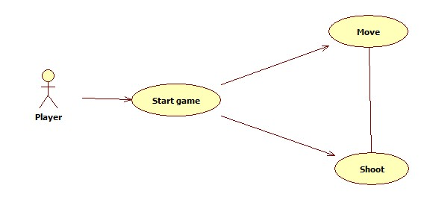

Because we are making a game for our project we have a relatively simple use case diagram. Our game is single player, so there is only so much that the player can do. The player can move around the gameplay area and can shoot enemies.

Class Diagram

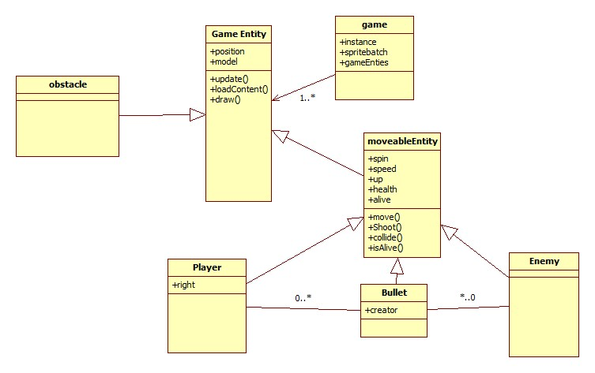

The structure of the game will involve three main objects. The player, the enemy and the bullets. Each of these includes their own model and textures. Bullets will be created and destroyed when they are used by the player and the enemy.

The game entity is what keeps all of the objects in the game in synchronisation. It will keep track of the status of the players and enemies. The objects are drew to the screen and then they use various functions to interact with the environment such as shoot() and move().

The three movable entities in the game are the player, the enemy and the bullet. Each of these share similar attributes and operations such isAlive, speed, move and collide.

Sequence Diagram

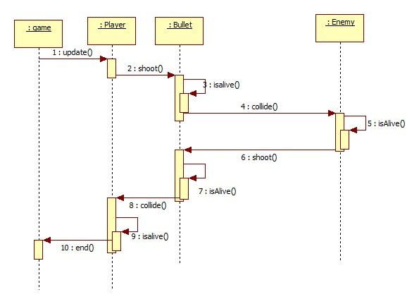

The sequence diagram above maps out what the player does when they are in the game. The player can shoot a bullet. The bullet travels until it either hits an enemy or hits some other obstacle. At this point the bullet exits the isAlive() state. If the bullet hits an enemy their health is checked and depending on whether their health hits 0 or not, they either continue on or get removed from the game.

GUI Prototype

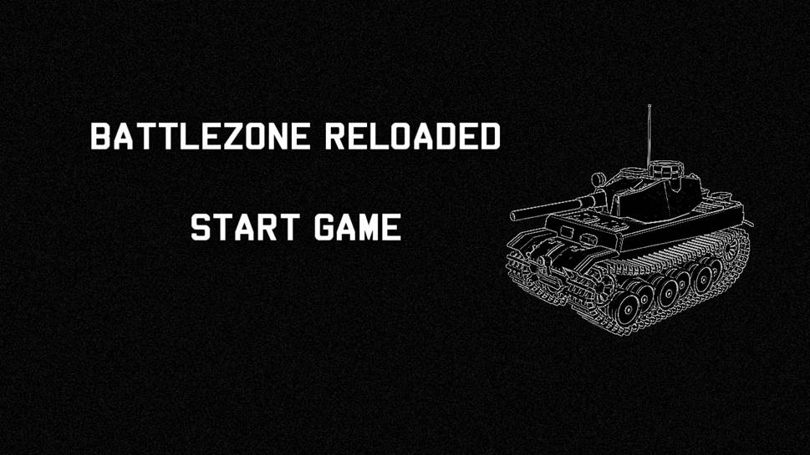

The above picture is a mock-up of when we would like our “start game” screen to look like.